EXPERIMENT 23
Implement the Top Hat Technique as a Morphological Operation Using OpenCV
Aim:
To perform the Top Hat morphological operation on an image using Python and OpenCV.
Procedure:
- Import OpenCV and NumPy libraries.
- Read the input image.
- Create a kernel.
- Apply Top Hat using cv2.MORPH_TOPHAT.
- Display the original and output images.
Program:
import cv2
import numpy as np

img = cv2.imread('image.jpg', 0)

kernel = np.ones((5,5), np.uint8)

tophat = cv2.morphologyEx(img, cv2.MORPH_TOPHAT, kernel)

cv2.imshow('Original Image', img)
cv2.imshow('Top Hat Image', tophat)

cv2.waitKey(0)
cv2.destroyAllWindows()

Input:

Output
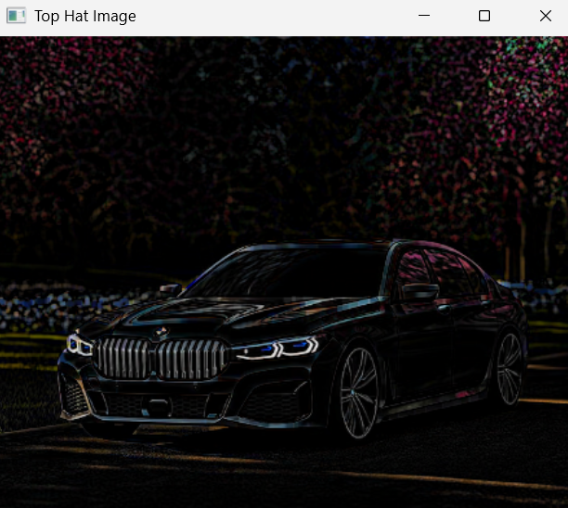
Result:
Thus, the Top Hat morphological operation was successfully performed to highlight small bright regions in the image.

